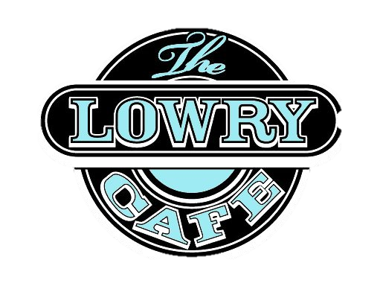  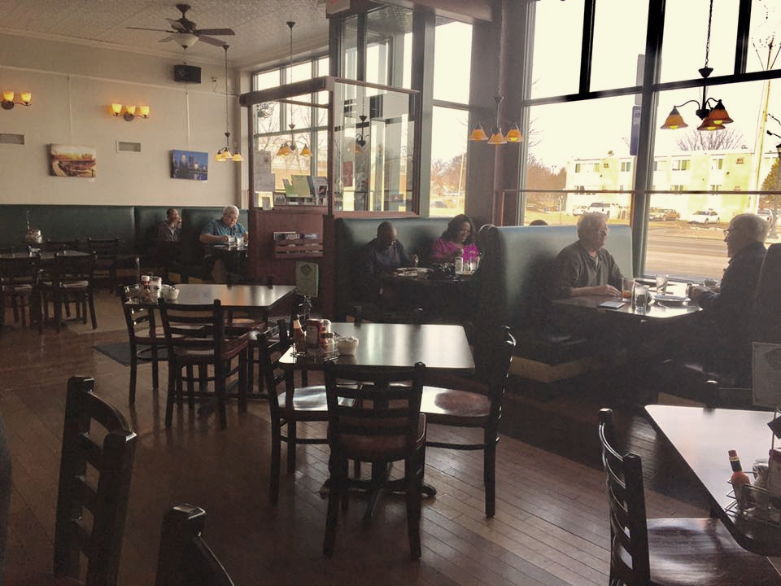  June 2nd, 2017  First Fridays!  Golden Thyme Café- 9:00 AM  Lowry Café- 12:30 PM  Let's come together as a community and talk about Restorative Justice, and what it means for us individually and as a collective of people working and living together. A great opportunity to have some meaningful conversations and pick the brains of your local Restorative Justice Advocates! | 9:00 AM- 10:00 AM  Golden Thyme Cafe  921 Selby Ave.  St. Paul, MN 55104  12:30 PM- 1:30 PM  Lowry Café  2207 Lowry Ave. N.  Minneapolis, MN 55411  July 7th, 2017  First Friday  Coming Soon  TBD Location & Time  RESTORATIVE JUSTICE COMMUNITY ACTION  101 East Grant Street  Minneapolis, MN 55403  Phone: 612.746.0787  Fax: 612.746.0789  Email: info@rjca-inc.org  www.rjca-inc.org  www.facebook.com/rjcamn  
*Not sponsored by Golden Thyme Café or Lowry Café

